Issues Observed during manual workflow :-

**1.** The following error appeared during addition of 5 products to cart manually without any tool.

User Interface error :

**Epic sadface: You can only access '/cart.html' when you are logged in.**

Client Side error : Failed to load resource: the server responded with a status of 404 ()

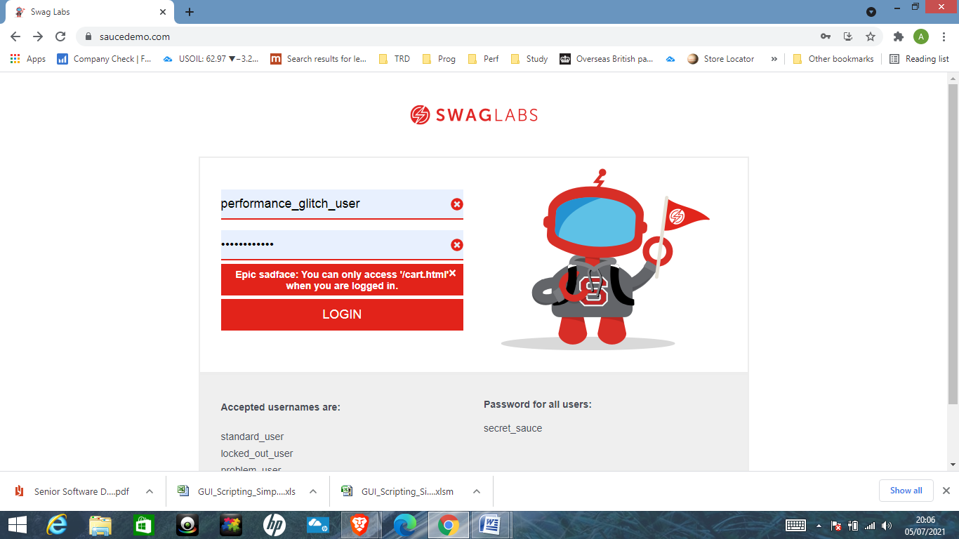

**2.** "YOUR CART " Page does not allow the user to modify the Number of Quantity(QTY) of products

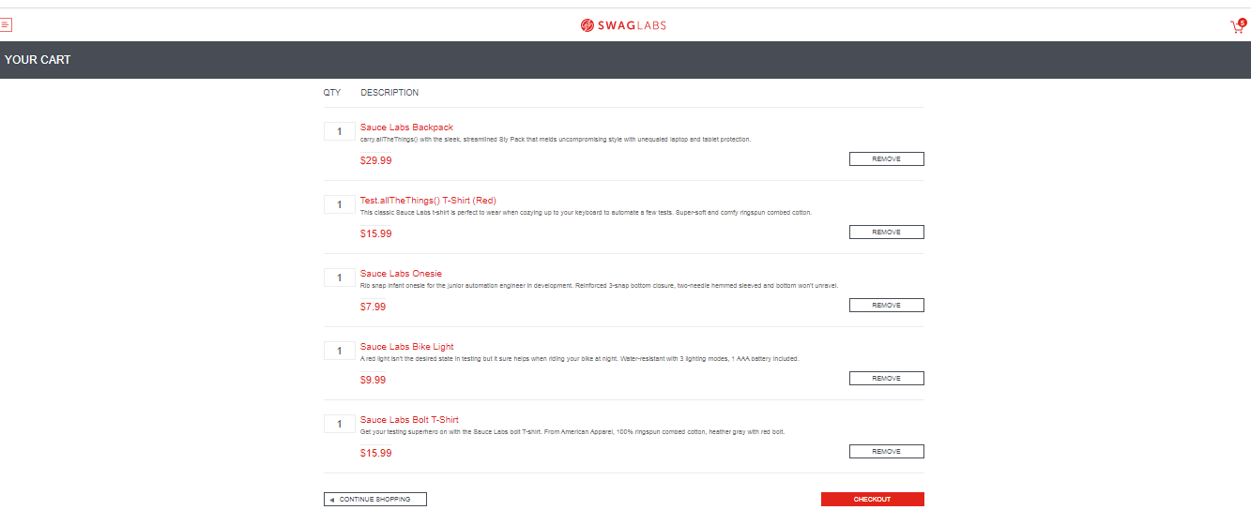

**3.** When the user clicks on the "Checkout " button the following error message is displayed .

Failed to load resource: the server responded with a status of 404 ()

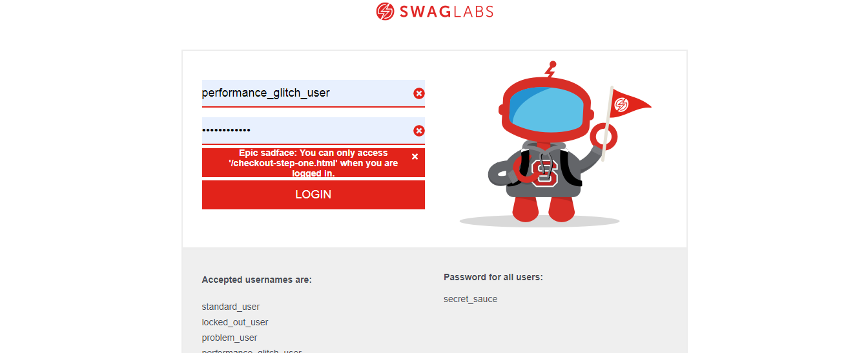

**4.** When the user clicks on the "FINISH" button the following error message is displayed .

"**Epic sadface: You can only access '/checkout-complete.html' when you are logged in."**

